## https://www.youtube.com/watch?v=YhYJYpSHTjA&t=785s

## Create Realm

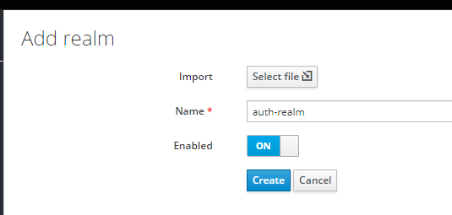

## Create a client

auth-client

Access type: confidential

Standard flow enabled: off

Service Account Enabled : on

## Create Roles

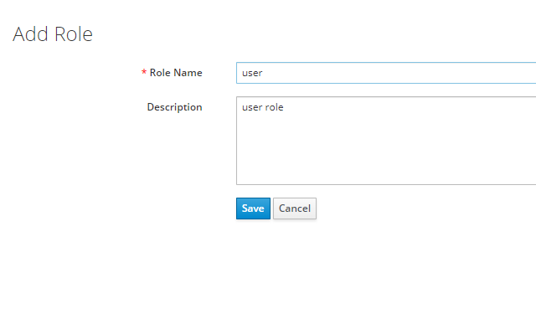

Create Users

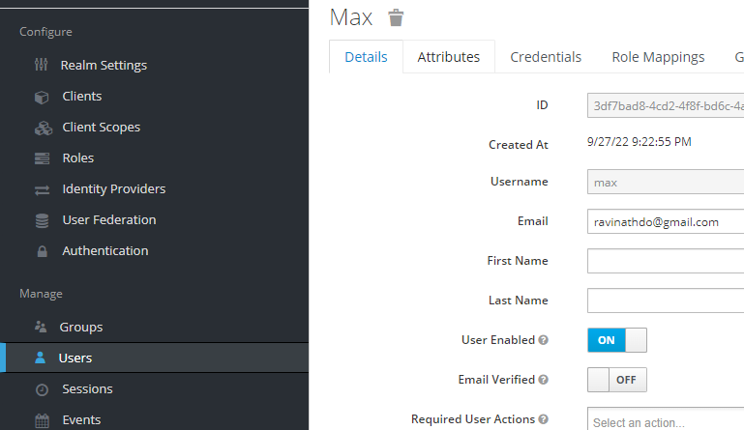

Create password and role mapping

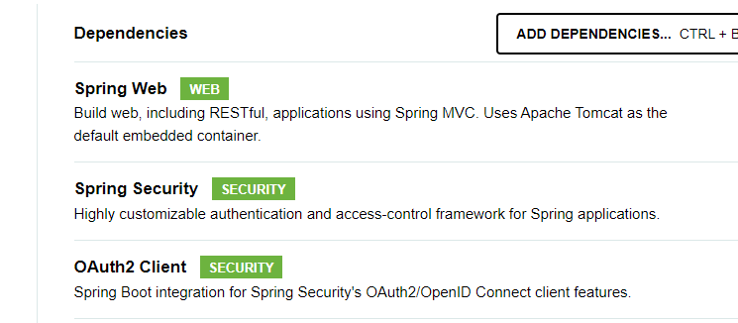

<dependency>  
 <groupId>org.keycloak</groupId>  
 <artifactId>keycloak-spring-boot-starter</artifactId>  
 <version>15.0.2</version>  
 </dependency>  
</dependencies>  
  
  
<dependencyManagement>  
 <dependencies>  
 <dependency>  
 <groupId>org.keycloak.bom</groupId>  
 <artifactId>keycloak-adapter-bom</artifactId>  
 <version>15.0.2</version>  
 <type>pom</type>  
 <scope>import</scope>  
 </dependency>  
 </dependencies>  
</dependencyManagement>